**WHO COMMANDS:-**

1 .who (how many user is online now) :-

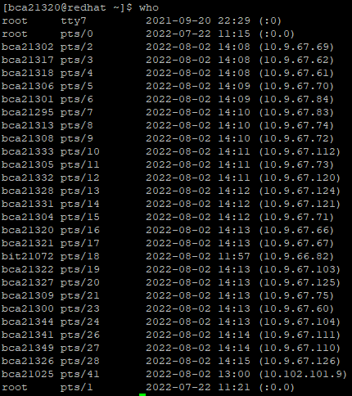

2. Who am I (my current id) :-



3.who -b:-



4.who –l:-

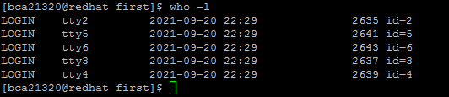

5. who –H:-

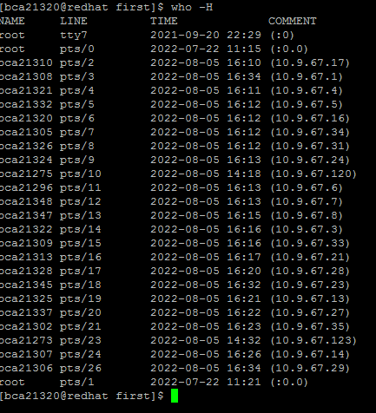

6.who –q:-

